FINAL REPORT

WEBSITE DEVELOPMENT

(EDUCATIONAL WEBSITE)

## Subject course code: CSE 326



|  |  |  |  |  |
| --- | --- | --- | --- | --- |
| **S.**  **No.** | **NAME** | **REG. NO.** | **ROLL NO.** | **SECTION** |
| 1. | M. Madhan Kumar | 11908148 | 34 | K19VQ |
| 2. | M. Sainath Chowdary | 11918253 | 35 | K19VQ |
| 3. | K. Tarun Krishna praneeth | 11904076 | 36 | K19VQ |

**Name of the Faculty** Moin Hassan

**Last Date for Submission of Project :** 10 April 2020

## TABLE OF CONTENTS

## S.no Page No.

## 1). Abstract 3

## 2). Introduction 3

## 3). Literature Review 4

## 4). Proposed Methodology 7

## 5). Result & Discussion 8

## 6). Conclusion 8

## 7). Reference 8

## Abstract :-

Our Project is based on Educational Website which provides free Educational Resources for all the students who are willing for Educating themselves. It contains many resources like E-books, Tutorial Videos and Online Forums and many more features. Mainly it is useful for the students who are currently persuading Class X to Class XII.

We also help the students who are willing to crack Competitional Exams also (JEE,AIEEE,BITSAT,SAT). Our Aim is to make Education accessible for everyone without charging any cost .

We Believe in Policy to make Education affordable to everyone.

“EDUCATION IS THE BIRTH RIGHT OF AN INDIVIDUAL. “

## Introduction:-

Our Website consists of Educational Resources which are useful for students who are currently persuading Class X and above. We provide them online textbooks(E-books) and other resources for their curriculum. We provide an easy way of learning via videos, and fun tasks. Our aim is to provide education accessible to everyone without charging any cost.

We strongly believe that Education is the birth right of everyone and hence everyone should use it.

Our website helps students for learning courses in a fun-filled manner. And it is a free source library for everyone globally.

Literature review:

This website of our Educational site named as Edu fun the features of this website are this provides a set of gallery which consists of the set of books from the Class X to 12 provides all the text book content with all the some videos an about us which defines the about our contributions and future plans of the welfare of website and contact us to contact us.

The Edu fun website is build based up on the basic html and cascading style sheets from the html I used to created a list of home, gallery, services, contact us, about us, then by using the Css given .

Hover effect of 0.6s time period with white hover effect then created a logo an set it at left corner of the website and background is placed by using Css , by this the background has given a gray scale effect .

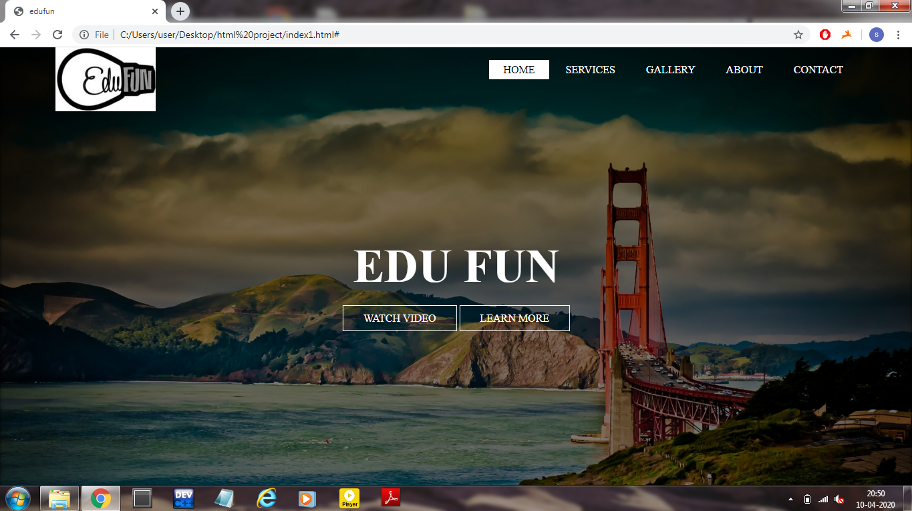

And the Edu fun is been written by html and placed in the middle by the Css and under that watch video and the learn more are been placed created as list by html and given styling by Css and hover effect also given of 0.9s.

Further this website is interlinked to the gallery under this all the text books are been placed and can be shown from class 10 to 12

At first all the thumb nails and the original images taken then in html created a

List where all the image links of thumb nails are been written then to those original size images are linked by using the Css this list is styled to be look like a formal gallery and a hover effect has been used for this as the cursor is moved that side of image it will show a hover effect divided from the class basis and separated .

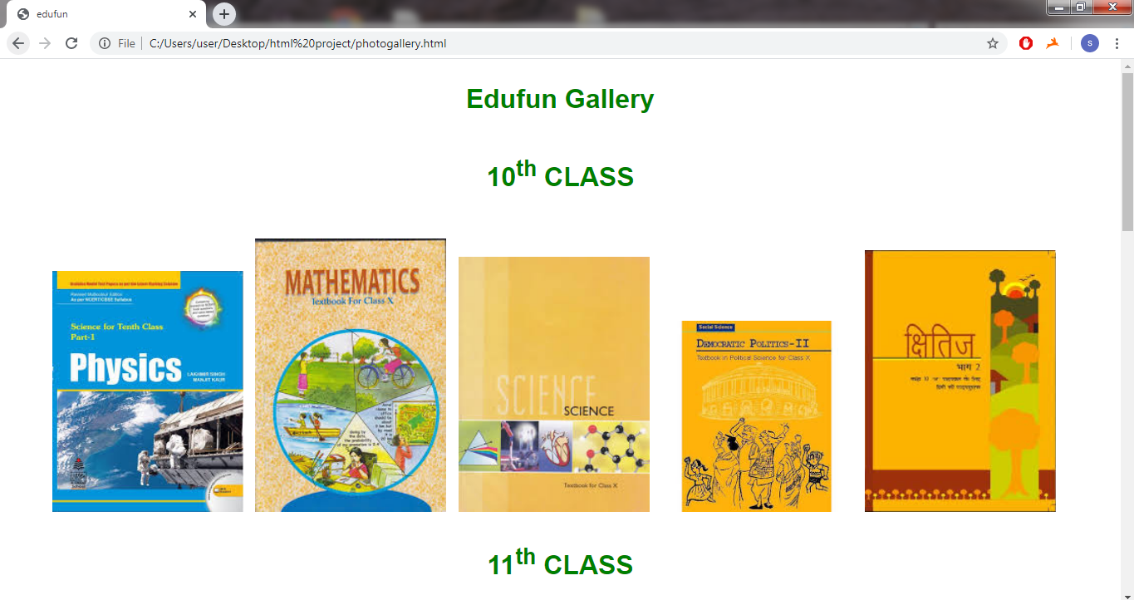

All the subject images are been placed according to the academic standard basis from this we learned about the using image links anchor tags by using these to create a gallery out figure and by using the Css we learned how to implement the hover effect on the each image all of them and when opened the thumbnail this is linked to anchor tag image link of the original image

From all this we have to create a perfect gallery

Then comes the contact us and about us these are written by using html in paragraph and then styled this body of the html by the Css by this given a background for both the contact us and about us.

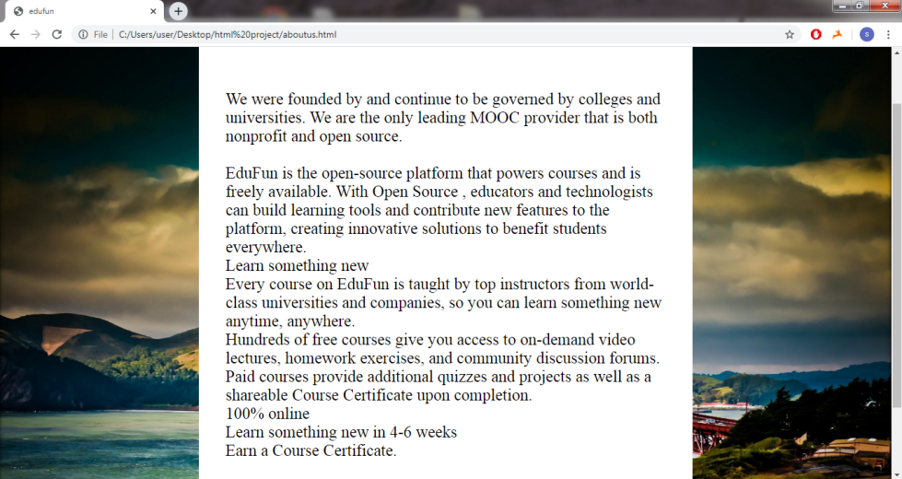

(About us)

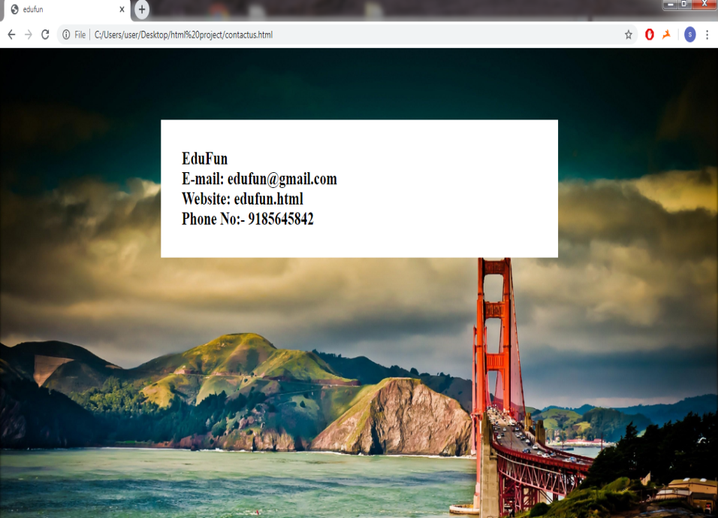

(Contact us)

From all this we got a perfect idea of creating a website and interlinking all the websites to the features of the website

## PROPOSED METHODOLOGY:-

For the development of our project we had followed some

principles/Methodologies most of them are discussed below.

1). Mainly for the development part of our website we had mostly used HTML and CSS .We started using basic HTML and CSS parts.

The Edu fun website is build based up on the basic html and cascading style sheets from the html I used to created a list of Home, Gallery, Services, Contact Us, About us, then by using the CSS .

2). We also added Hover Effects for the better view of our website.

Hover effect of 0.6s time period with white hover effect then created a logo and set it at left corner of the website and background is placed by using CSS , by this the background has given a gray scale effect .

3). Next we added images and logos for our website .

Further this website is interlinked to the gallery under this all the text books are been placed and can be shown from class 10 to 12.

All the subject images are been placed according to the academic standard basis from this we learned about the using image links anchor tags by using these to create a gallery out figure and by using the CSS.

4). We had created and added details to our website.

Contact us and about us these are written by using HTML in paragraph and then styled this body of the html by the CSS by this given a background for both the contact us and about us.

## Results:-

By following the methodologies we had successfully created an Educational Website . So the students can access it anywhere and at any time when they are in need.

## Conclusion:-

We are able to create an website which helps the students with many educational resources like E-Books , PDF’s and many other in a fun and easy way. As our website is an open source community everyone has access to it anywhere.

## References:-

1. <https://www.w3schools.com/html/>